Case 10-AM,S-Peru-Inca-T-shaped Axe Head-Vesicular Andesite-1400 CE

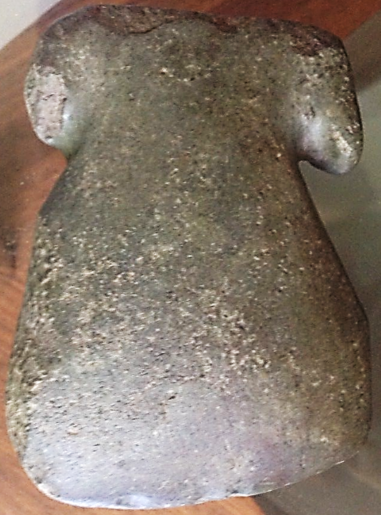

AM,S-Peru-Inca-T-shaped Axe Head-Vesicular Andesite-1400 CE

**Case No.: 10**

**Accession Number:**

**Formal Label:** AM,S-Peru-Inca-T-shaped Axe Head-Vesicular Andesite-1400 CE

**Display Description:**

Pre-Columbian Inca 'T' shaped axe head, with base slightly concave, nicely executed grooves and sharp blade, carved in dark green vesicular andesite. The major weapons of an Inca warrior were the T-shaped axe or halberd and the spear.

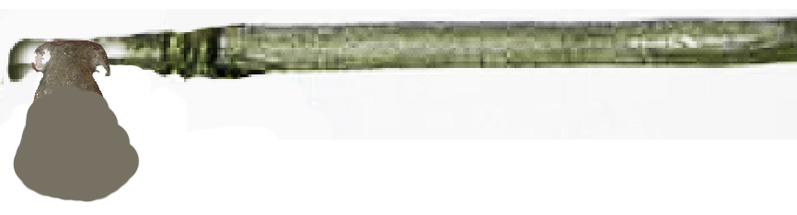

T-shaped axe hafted.

**LC Classification:** F3429.3

**Date or Time Horizon:** 1400 CE

**Geographical Area: Peru**

**Map:**

**GPS Coordinates:**

**Cultural Affiliation:** Inca

**Medium:** dark green vesicular andesite

**Dimensions**:   
**Weight:**

**Provenance:**

**Condition:** Overall fine condition, with chips around one auricle or hafting place.

**Discussion:**

**References:**

Malpass, M.A., 1993. *Provincial Inca: Archaeological and ethnohistorical assessment of the impact of the Inca State*. University of Iowa Press.